Create Azure function that read message from device

Do to list

* Create Azure IoT Hub
* Provision a device
* Create device sim in Visual studio
* Make sure the device send message to cloud successfully. Use Win app “device explorer” to monitor message
* Create Azure function app
* Create Azure function
* Make sure function is trigged by IoT Hub event
* See function’s log for the message from device.

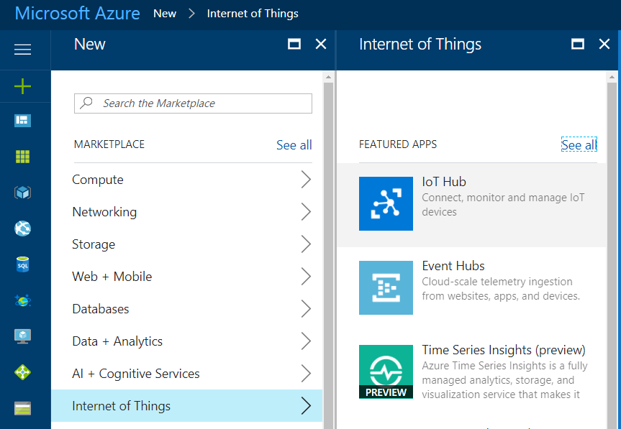

Create Azure IoT Hub

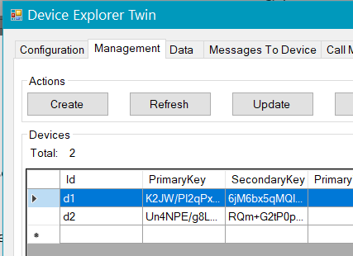

Provision device

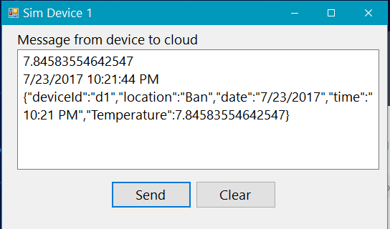

Create device sim

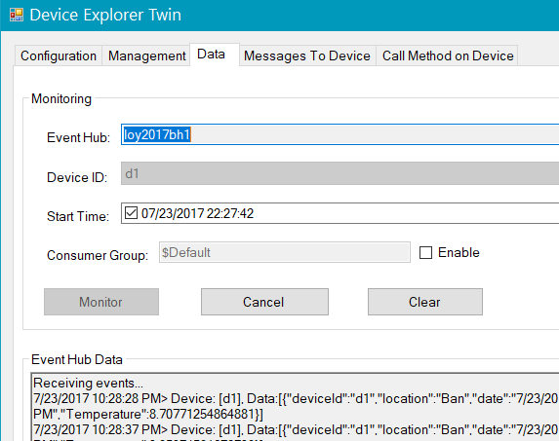

Make sure can send message to cloud. Use Win app “device explorer” to monitor message

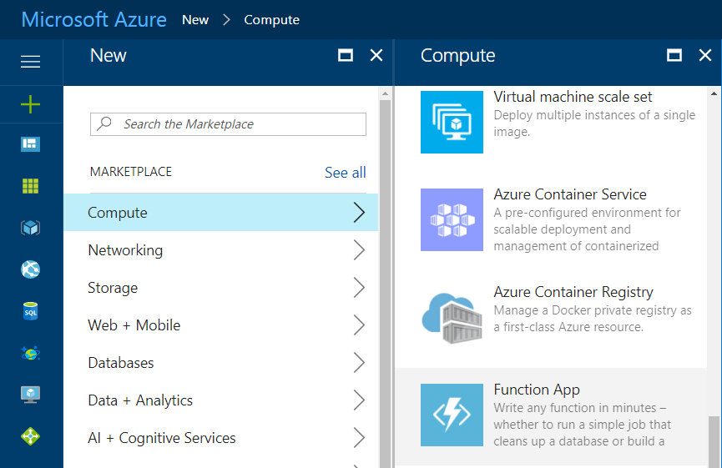

Create new Function App

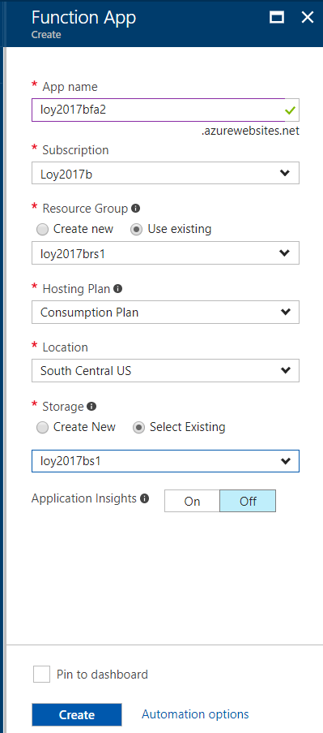

Function app properties

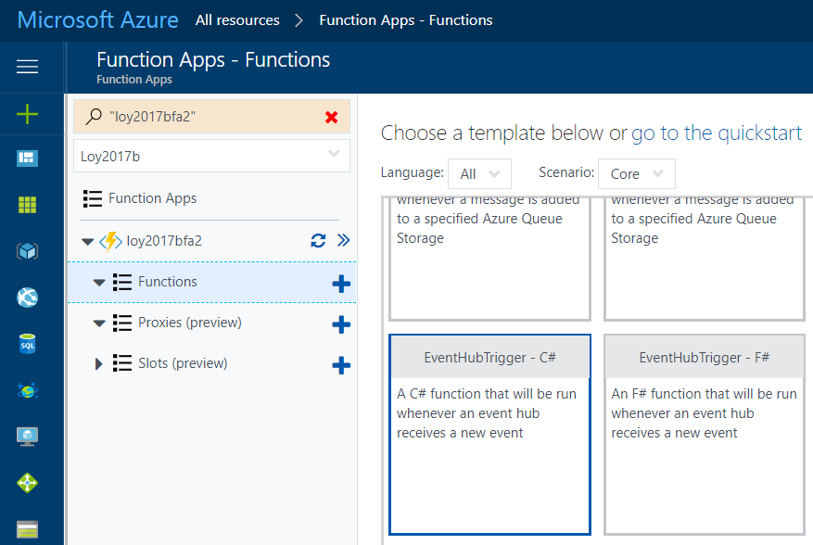

Create new function “EventHubTrigger – C#”

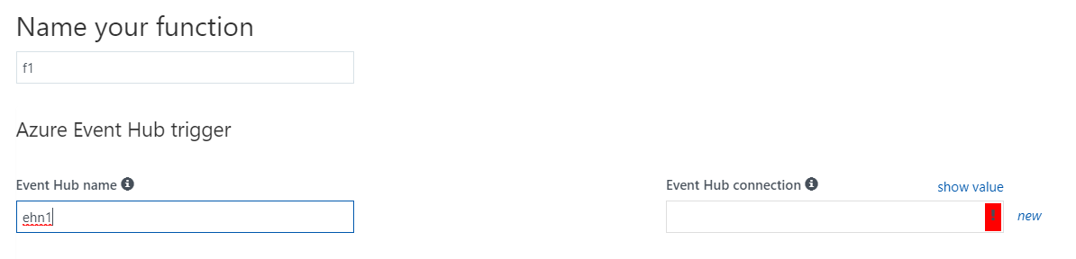

Click New

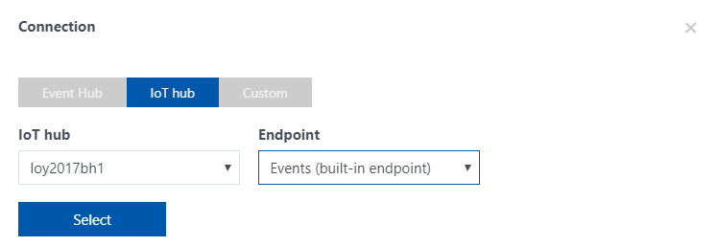

Click IoT hub / Select

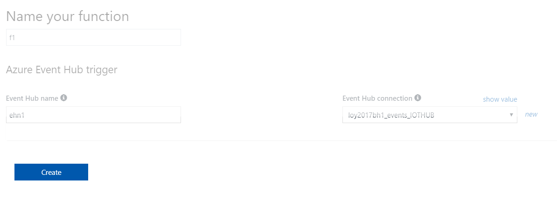

Create

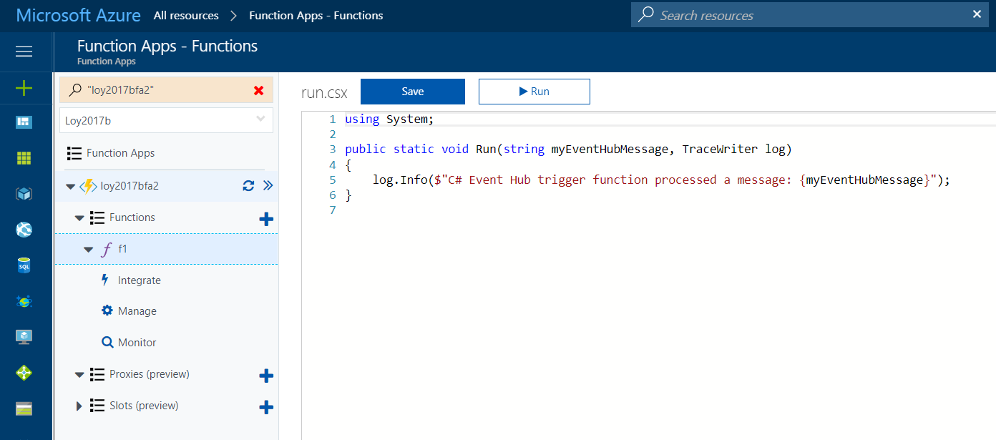

Now we have the function

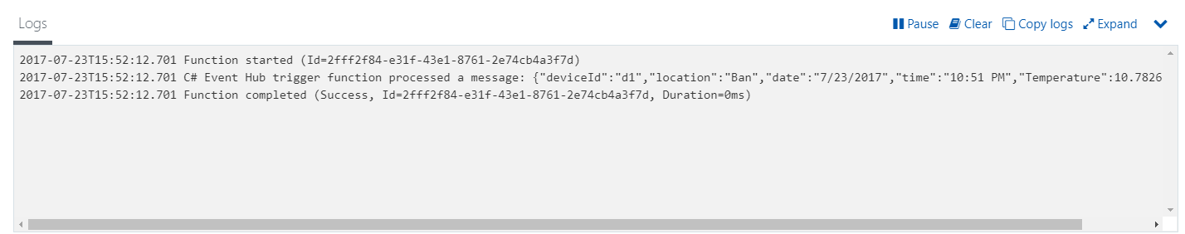

Send message from Device and look at the Logs of Function, you should see the message